

## Creating a Parent Portal Account

1. Open a web browser (Firefox, Safari, or Internet Explorer), and enter this web address: **powerschool.sandi.net** or click on the Parent Portal Link on our website.  
   The window changes to the following:

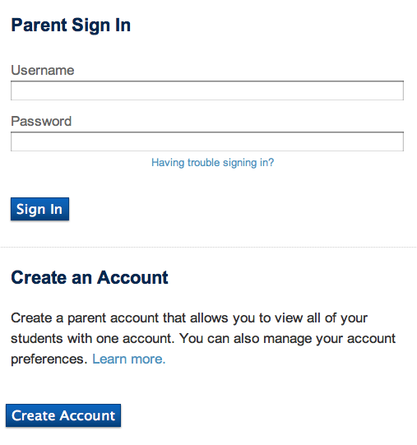

1. Simply click **Create Account** at the bottom of the window (without typing anything in the blank fields).

# Parent Portal Login Information

## Creating a Parent Portal Account

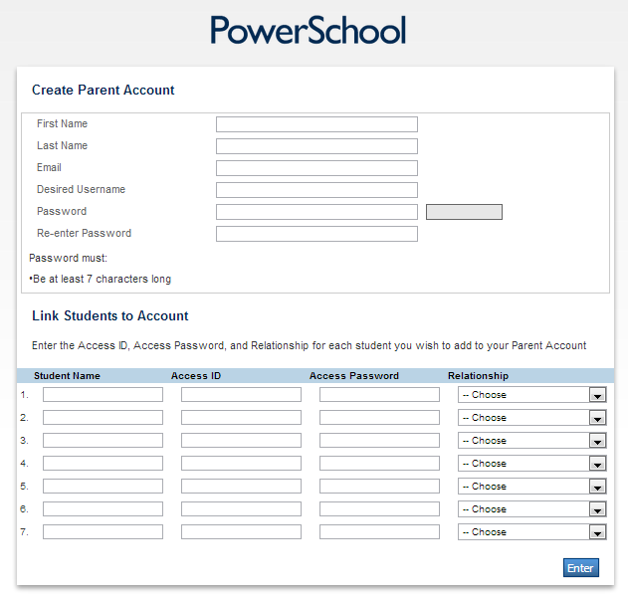

1. In the Create Parent Account area at the top of this window, enter your name, email address, a Desired Username that you will enter every time you log in to the Parent Portal, and a Password that you will enter every time you log in to the Parent Portal.

The password must be 7 characters or more.

1. Enter your child’s name, Access ID, and Access Password. (Access ID and Access Password provided above.) Choose your Relationship to the child from the drop-down menu.  
   If you have other children enrolled in San Diego Unified School district, enter their names, Access IDs, Access Passwords, and Relationships.

PowerSchool Parent Portal

1. In the blank **Username** field, enter the Username you just created.
2. In the blank **Password** field, enter the password you just created.
3. Click **Sign In**.

**Attendance**

View attendance totals and an attendance grid for the term.

**Grades + Assignments**

View your student’s grades, assignment scores, citizenship grades, and credit hours.

**Teacher Comments**

View general comments by your student’s teachers.

**Email Notification**

Receive various email notifications from the school.

**School Bulletin**

Read daily announcements.

**My Calendars**

Subscribe to your student’s class assignments, scores, and final grades calendars.

**Account Preferences**

Change your profile information, and add students to your account.

# What You Can Do in the PowerSchool Parent Portal!

1. In the blank **Username** field, enter the Username you just created.
2. In the blank **Password** field, enter the password you just created.
3. Click **Sign In**.

## Signing In to Your Account After Your First Time (cont’d)

1. Open a web browser (Firefox, Safari, or Internet Explorer), and enter this web address: **powerschool.sandi.net**  
   The window changes to the following:

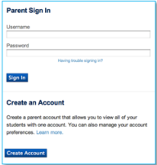

## Signing In to Your Account After Your First Time

## Signing In to Your New Account for the First Time

1. Click **Enter**.   
   The window changes to the following:

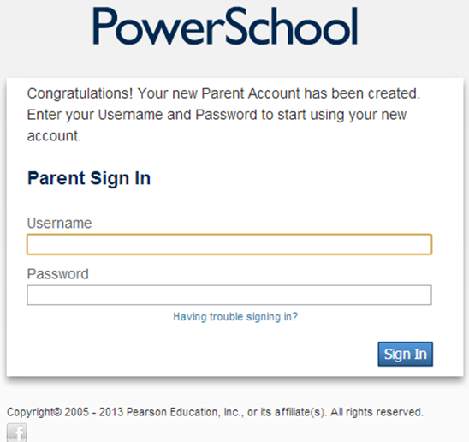

## Creating a Parent Portal Account (cont’d)

PowerSchool Parent Portal (Page 2)